Assignment 2: A* Search

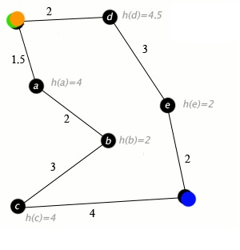

You are given a graph where the nodes denote cities and each edge denotes the distance of two connecting cities. Each node has a heuristic associated with it. The heuristic is the actual geological distance between a city and the destination city (Blue node). Now find the shortest path from the starting city (yellow node) to the destination city.

Recall that in A* search, the cost of a node can be denoted by a function where:

f(n) = g(n) + h(n)

Here, = Known cost of getting from the initial city to n.

$h\left(n\right)=$ Heuristic estimate of the cost to get from *n* to the destination city.

Note that, you should use Dijkstra to find $g(n)$. The heuristic value for each node n, $h\left(n\right)$ with respect to a goal node will be provided in the input set.

**Input:**

7 7 (Graph Dimension)

***s*** (Starting Location)

***f*** (Destination Location)

s d 2

s a 1.5

a b 2

b c 3

c f 4

e f 2

d e 3

s d 2

s 10

a 4

b 2

c 4

e 2

d 4.5

f 0

**Output:**

Shortest Path from source **s** to destination **f.**

**[Try Yourself ☺ ]**